A000-AM,C-Guatemala Olmec-Pendant-Were-Jaguar-Green Jadeite-1050 BCE.

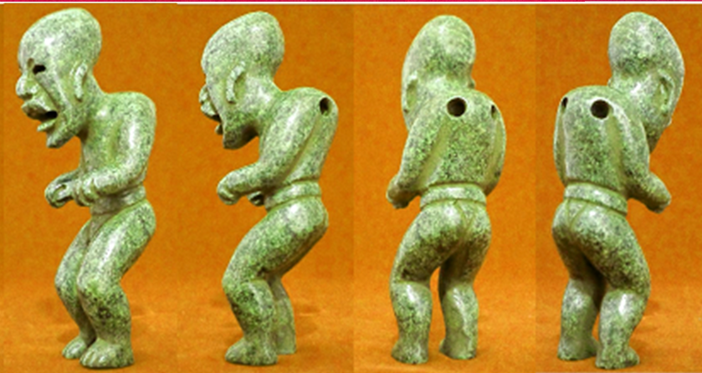

AM,C-Guatemala Olmec-Pendant-Were-Jaguar-Green Jadeite-1050 BCE

Case No.:

**Accession No.**

**Formal Label:** AM,C-Guatemala Olmec-Pendant-Were-Jaguar-Green Jadeite-1050 BCE

**Display Description:**

This ceramic theriomorph, in the process of transforming from a human into a jaguar, is undergoing the bending on its knees and feet so that it conveys the process of transformation from a shaman into a jaguar: it is in the active process of standing on all four legs. Additionally, the accentuation of making sounds like a jaguar are being articulated with its open mouth which is also being transformed into the shape of a jaguar’s. He has a flared nose, up-curved upper lip which is intended to emulate the jaguar's snarl, as he bares a row of evenly filed teeth. The élite status of this individual is indicated by the deformation of his head, a mark of high caste. The waist belt may also indicate that this individual has engaged in the ball game.

**LC Classification: F1219**

**Date or Time Horizon: 1050 BCE**

**Geographical Area: Guatemala**

**Map:**

**GPS coordinates:**

**Cultural Affiliation: Olmec**

**Medium:** Green Jadeite

**Dimensions** Height: 3.25 in

**Weight**: 1.9 oz

**Condition: original**

**Provenance:**

**Discussion:**

**References:**

Furst, P.T., 1968. *The Olmec were-jaguar motif in the light of ethnographic reality* (No. 8). Univ. of California.